Slovak MTBO championships 2026
Invitation
Open Slovak MTBO championships
13th and 14th round of the Czech cup
MTBO competition for the general public

Organizer |  | Slovak Orienteering Association (SZOŠ)
Technical support |  | ŠK VAZKA Bratislava
Webpage |  | http://mtbo.vba.sk/2026/
Date and classification |  | Open Slovak MTBO championships on Middle and Long  Czech MTBO cup – 13th and 14th round
Date |  | 19.9.2026 (Saturday) - Middle  20.9.2026 (Sunday) – Long
Event Center |  | Amphitheater Rača (map)
Presentation |  | Saturday) - 9:30 - 11:00 at the event center  Sunday) - 08:00 - 09:00 at the event center (only for competitors who didn’t participate in Saturday’s races)  On-site entries according to the capacity of the organizer.
Classes |  | M12, M14, M17, M20, M21E/ME, M21A/M21, M21B/MB, M40, M45, M50, M55, M60, M70  W12, W14, W17, W20, W21E/WE, W21A/W21, W21B/WB, W40, W50, W60  MW10 – possible for parents to accompany the child  Open - for beginners of any age and gender  In bold are written master classes, i.e., classes in which the title “Master of the Slovak Republic in MTBO for 2026” will be awarded.  At least 3 competitors must start in the class to be awarded the master’s title.  In case of a small number of registered users, there is a possibility of merging some categories.
Estimated winners |  | According to Rules Pravidiel OC SZOŠ
Punching system |  | SportIdent, contactless system AIR+, will be used (allows embossing to a distance of 150-200 cm). Finish control will be set for both manual stamping and AIR +.  (SI rental: 2 € / day, in case of damage or non-return: 40 €)
Entries |  | till 13.9.2026, 23:59  Login instructions:  All competitors must register through the Czech ORIS information system  https://oris.orientacnisporty.cz/  The races have a simplified name in the system:  - Saturday, 19.9.2026 - Czech MTBO Cup - 13th round  - Sunday, 20.9.2026 - Czech MTBO Cup - 14th round  Registration for the race can be created only after logging in to the ORIS system! Competitors who are not members of a club registered in ČSOS must first create a user account in the ORIS system.  Unregistered competitors will also use ORIS registration in the form of a one-time application.  Applications after the deadline to email prihlasky@vba.sk only within the capacity of the organizer (valid only after confirmation) and for a surcharge of 50%.
Entry fees
  classes | fees
  WM10 | 2 €
  WM12, WM14, OPEN | 5 €
  WM17, WM20 | 8 €
  WM60, M70 | 12 €
  Other categories | 14 €
Payment method |  | Bank transfer in EUR  IBAN: SK61 8330 0000 0028 0137 8686  BIC/SWIFT: FIOZSKBA (Fio Banka - SK)
Terrain description |  | Small Carpathian hilly and vineyards with a dense network of various roads and trails with various drivability
Map |  | Saturday - 1:12500/1:15000, equivalent = 5 m, as of August 2026, size A3/A4  Sunday - 1:10000, equivalent = 5 m, as of August 2026, size A3/A4
Start 00 |  | 19.9.2026 (Saturday)  At 12:00.  Interval start according to the start list.  20.9.2026 (Sunday)  At 9:30.  Interval start according to the start list.
Distances |  | Event center – presentation 0km  Event center – parking 200m - 3km  Event center – start up to 3km  Event center – finish up to 3km
Map holders |  | Possibility to rent at the presentation for a 2€ fee.
Accommodation |  | Accommodation options are described in Appendix 1
Catering |  | Bring your own supplies for the course; drinking water and sports drinks will be available at the competition center. A snack bar is available at the race center.
Parking |  | Please park according to the organizers’ instructions. The competition center is located in a busy residential area with limited parking, so please keep this in mind. It is also a very popular tourist destination on weekends, so we recommend arriving early.  Parking Lot P1 near the swimming pool in Knížková Valley (capacity: max. 30 cars; NO RVs allowed)  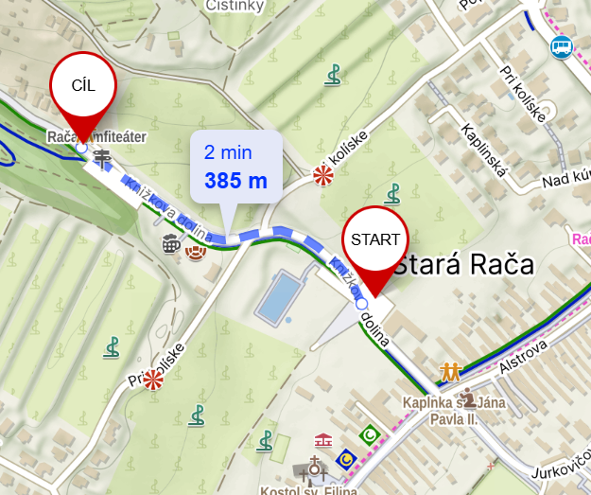  Parking Lot P2 behind the amphitheater in Knížková Valley (capacity: max. 30 cars; NO RVs allowed)  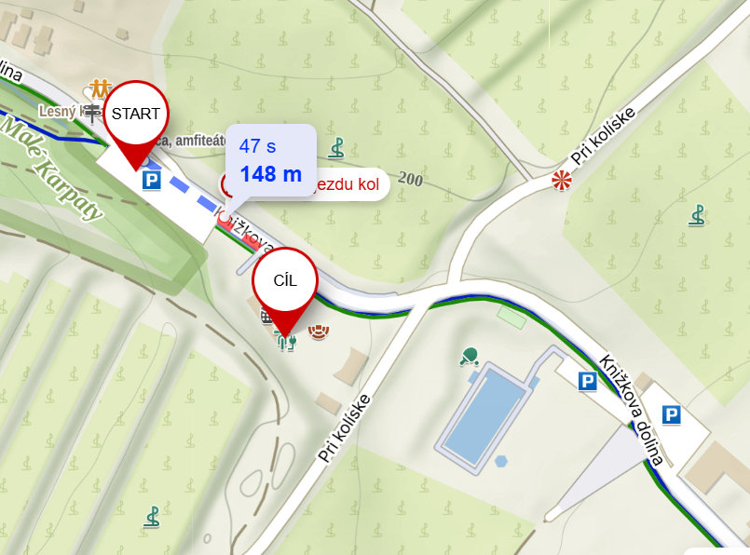  Parking Lot P3 – Potočná Parking Lot (capacity: max. 25 cars; NO RVs allowed)  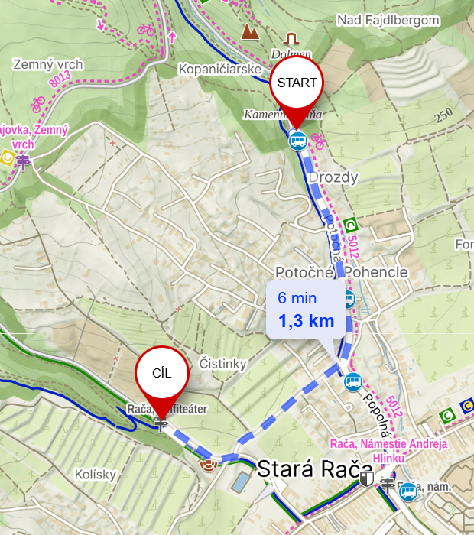  Parking Lot P4 – parking lot next to the Kaufland shopping center (suitable for both passenger cars and RVs)  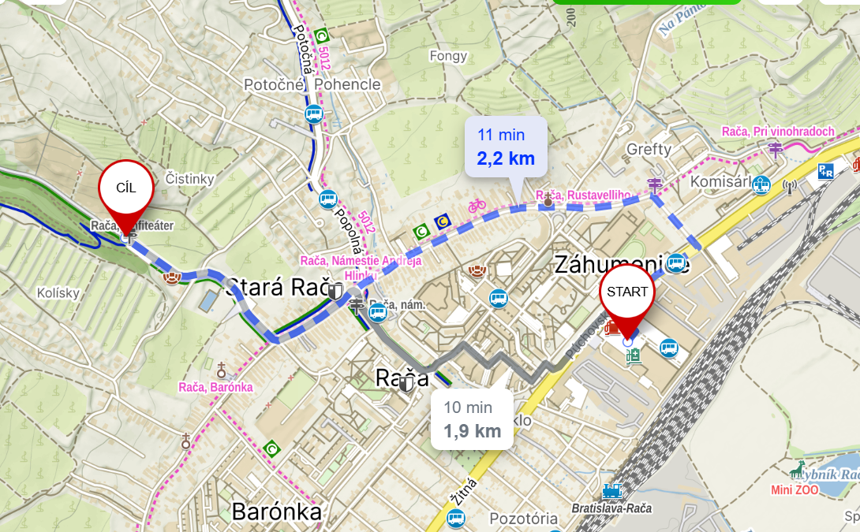  Parking Lot P5 – Komisárky P+R Park-and-Ride (suitable for both passenger cars and RVs)  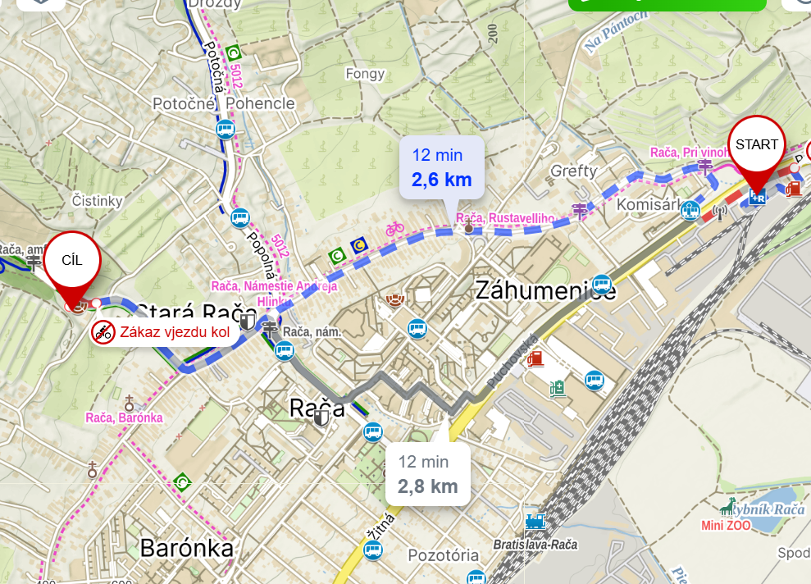
Nursery |  | At the Event center, a picture track will also be available
Bicycle Storage |  | The organizer does not provide this service.
Prize-giving ceremony |  | Will be held after each race. The first three in each category will receive medals and prizes.
Complaints |  | In writing to the main referee, deposit 10 €.
Forbidden area |  | Is marked on the map  - By red hatching in the case of a forbidden area,  - Red zigzag line in case of a forbidden road  - No off-road movement - the competitor must use only the road when completing the course; he/she must not move on a bicycle in open terrain.
Additional Notice |  | Sales or promotional activities may only be conducted with the approval of the event director.
Contact |  | katarina.papugova@gmail.com
Officials |  | Event director: Katarína Müller Papugová (tel: +421 907 646 551)  Main referee: Barbora Šmelíková  Course planner: Miroslav Lago/Matej Müller (middle)  Peter Mlynárik/Stanislava Ančicová (long)  Competition secretary: Eva Králová  Map and graphics: Miroslav Lago  Web admin: Adam Müller
Approval Clause |  | The rules were approved by the MTBO Section (SR) and the MTBO Competition Committee (CZ) on May 29, 2026.

Warnings: Competitors accept the hazards associated with participating in the event, and that they take part at their own risk, are responsible for their safety, and have no claim against the Organizer in case of injury during the event, or caused by it later on. Marketing and sales activities at the event center only with the director's permission. By taking part in the event, every participant consents to storing his personal data (name, class, club) in the information system of the Slovak Orienteering Association and publishing them on the event websites (in entry and start lists and the results). Unless you ask the photographer for a specific exclusion, by taking part in the Event, you consent to be photographed and waive any rights of publicity or privacy and grant the Organiser permission to utilize your image in documentation and marketing materials.
Partners
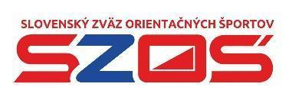 |  | 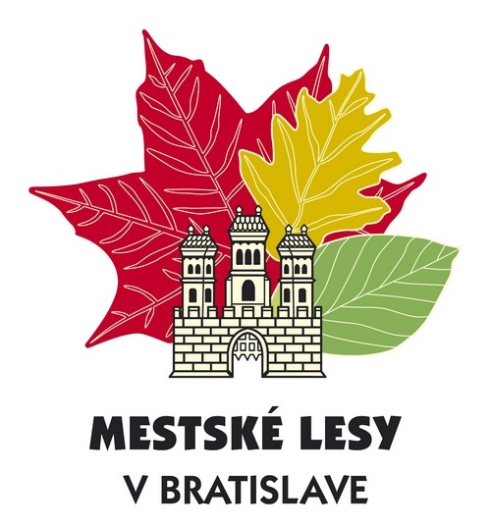
https://www.orienteering.sk/ | https://www.raca.sk/ | https://www.mlba.sk/
 |  | 
https://www.lesy.sk/ | http://www.autrata.sk/ | https://www.metrostav.sk/
 |  | 
https://bratislava.sk/vzdelavanie-a-volny-cas/starz | https://aonenutrition.com/

Appendix 1 - Accommodation Options

Camping Zlaté piesky
For more information about the campground, visit https://bratislava.sk/vzdelavanie-a-volny-cas/starz/prevadzky-sportoviska/kemping
Accommodation options include cabins (2–4 people), tents, or RVs
The shortest distance from the campsite to the race center is 7.2 km
Facilities
- electrical hookups and access to drinking water,
- dumping stations for liquid waste and chemical toilets for RVs,
- renovated restrooms, a kitchenette, and a laundry room.
- the campground is also adapted for visitors with pets, which are allowed on a leash; there are also designated dog runs on the premises.
- the area surrounding the campground offers a wide range of sports and recreational activities: a swimming pool, a lake with water sports (wakeboarding, paddleboarding, boating), beach volleyball, tennis courts, and gazebos with barbecue facilities.
Price List
- Compared to the current price list, competitors receive a 10% discount
- Reservations - by email to reservation@camping.bratislava.sk or by phone at +421 903 742 872 (please include "MSR MTBO 2026" in the email subject line)

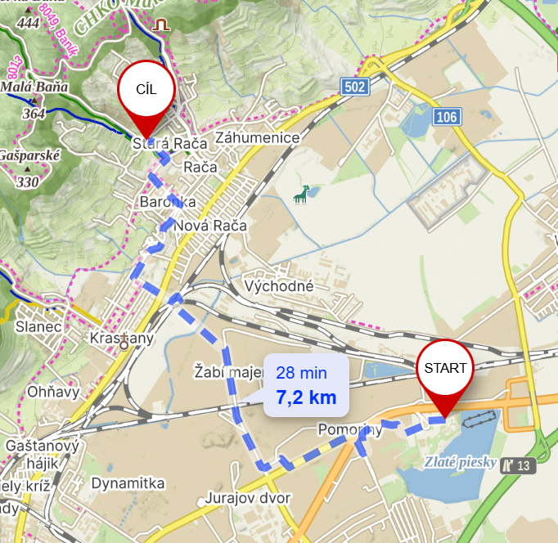

Huntry camp
- Space is very limited
- You can find all the information on their website at https://www.huntrycamp.sk/
- The shortest route from the campground to the race center is 4 km
